Virtual Exchange Service Connector Setup Guide

Introduction
The virtual Exchange Service Connector (VESConnector) is a component for establishing secure network connectivity between virtual node in the cloud and database server in your enterprise environment without opening firewall for any inbound connections. VESConnector only needs outbound connections to trusted MS ISB. It uses several layers of security to safeguard the access:
- Token Authentication: The virtual node connector connects to the Azure Service Bus using a secure authentication token.
- Transport Security: All communications between your node and database server are encrypted and signed through TLS.
- Application Authentication: Database layer authentication is enforced by the virtual node. All incoming request to database servers are authenticated.
- Node Access: All requests to Virtual Node must be authenticated through NAAS.
The VESConnector can be installed on any Windows Server if it has local network connectivity to the database server.

System requirement
- Window 64bit system with database server such as SQL server, Oracle, Sybase.
- .Net Framework 4 64-bit Full version.

Installation steps
- Unzip VESConnectorSetup.zip in a proper temporary folder.
- Uninstall previous version if one exists.
- Click setup.exe in the temp folder to start the installation.
- Click the next button when the first wizard screen is displayed as shown below.
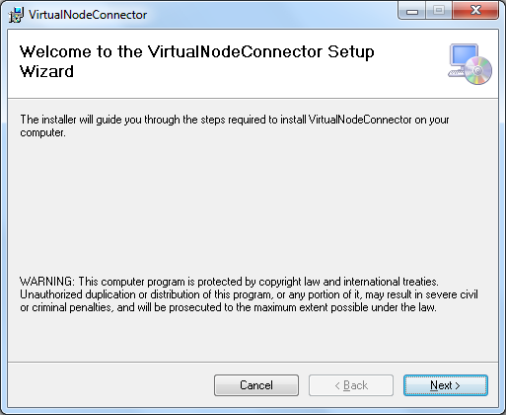

  - Select a file folder to install the connector or use the default when the second screen is displayed. Then click the next button again.

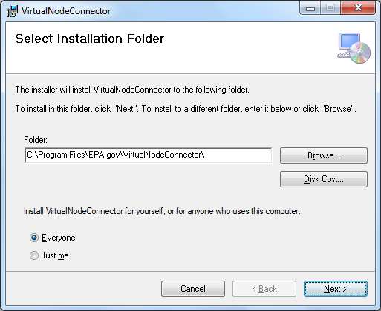

  - When Service Bus Configuration screen is displayed, input namespace and token supplied, then click the Next button.

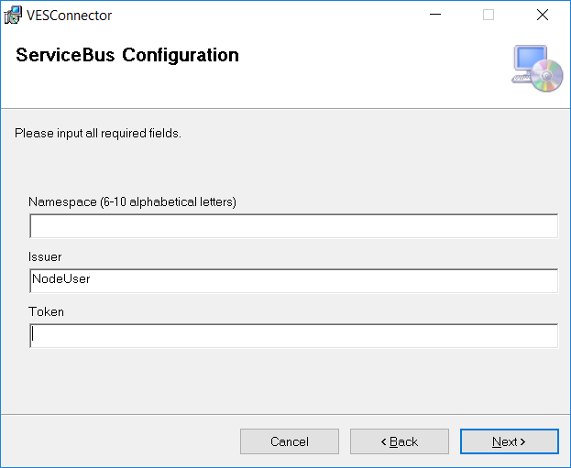

  - When Resource Configuration screen is displayed, input the internal IP address and port for your database server, e.g. 192.168.0.10:1433. You may configure more than one database server with different IP addresses separated by commas. Click the next button after completing the form.
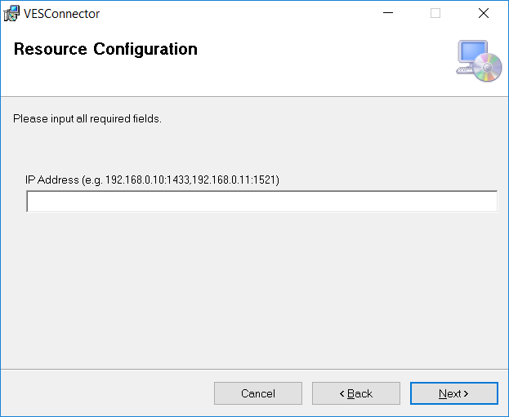

  - Click the next button when the confirmation screen is displayed.

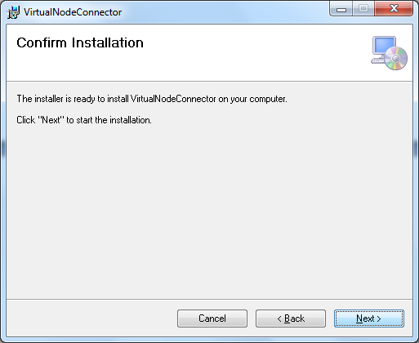

  - Click “Yes” when the user account control window pops up. Then wait until following screen is displayed. Click close to complete the installation.

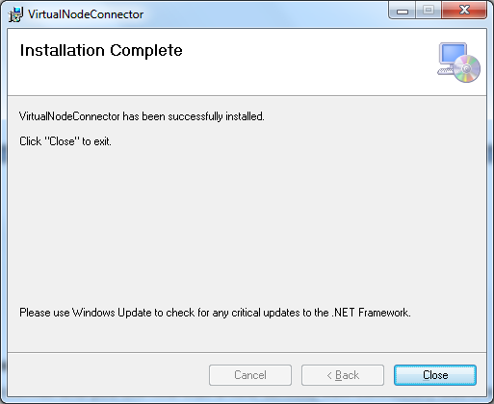

- Start the windows service
Open services.msc and you will find that a new service, VES Connector, was created and is running. If the service has not started automatically, start it manually. Please contact us for help with any troubleshooting.

Using Virtual Exchange Service Connector

Once your connector is up and running, you need register your remote database with your Sub Namespace and the database local IP address as shown below.
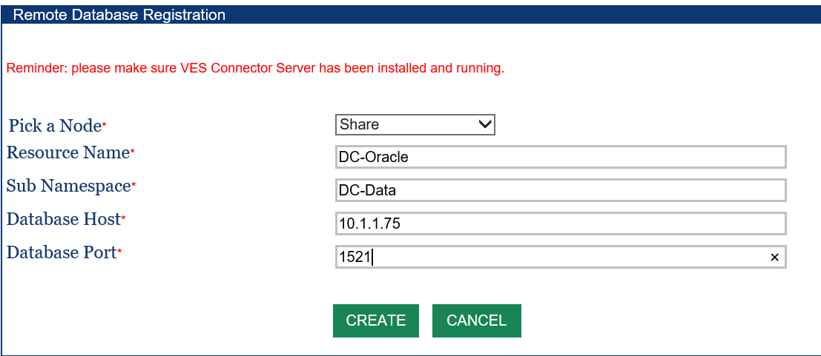
We will assign a special VESConnector port associated with your Sub Namespace. This will be the port to setup your Data Source as shown below. Please consult the Virtual Node Administrator’s Guide on how to setup Data Sources for accessing your databases using the virtual node.
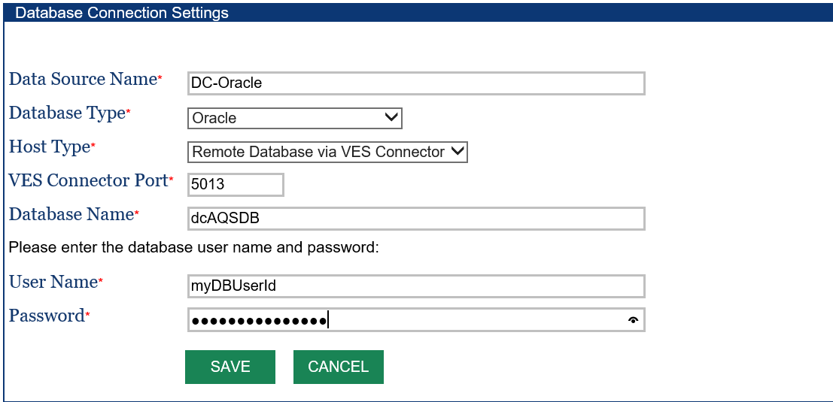
In the DataSource screen above, you can see that the VESConnector has made your remote database server accessible to VES.

Trouble Shooting and Support

The VESConnector writes activity and error information in a log file in the directory where it was installed. It usually contains detailed information on exceptions when an error occurs. Please contact VES Support at ves.support@innovateteam.com if technical support is needed. Although VESConnector does not require changes in firewall setting usually, some states block outbound connections. In these cases, two firewall rules need to set as shown below:
- Allow outbound connections from VESConnector to MS ISB server at 168.62.48.238;
- Allow outbound connections from VES Connector to all MS ISB resources at port 9350, 9351 and 9352, i.e. *.*.*.*:9350-9352.

Modifying Connector Configuration after Installation

The Virtual Node Connector has a configuration file named
VESConnectorserver.exe.config
in the directory where it was installed (the default directory is c:\Program Files\EPA.gov\VESConnectorServer). You may make changes of settings in the AppSettings section. The section contains configuration as shown below:
<appSettings>
<add key="issuerName" value="owner"/>
<add key="issuerSecret" value="Lx1YSC9DhlENj6vLUqCKeyValue="/>
<add key="servicePath" value="sb://nodedb.servicebus.windows.net/cdx"/>
<add key="allow" value="MyDB.MyDomain.com:1433"/>
<add key="waitMin" value="1"/>
</appSettings>
The Items in the configuration sections are :
- issuerName: The name of the service bus issuer. It is used for authenticating to the Azure Service Bus.
- issuerSecret: This is an encrypted secret for authenticating to the Azure Service Bus. A new set of issuerName and issuerSecret should be used when the servicePath changes. The issuerName and issurerSecret are issued by the Virtual Node host administrators.
- servicePath: This is the URL where the Azure Service Bus can be reached.
- allow: The entry controls which host and port can be accessed through the service bus. It should contain your database server’s name (or IP address) and port. This is the entry to be modified accordingly when your database server changes.
- waitMin: This is the number of minutes to wait before reestablishing network connection to the Azure Service Bus if a network connection was disrupted.

